TNO report

Mapping routines in GEOMEC 3
Date | 30 September 2003
Author(s) | A.H.D. Willemse

Copy no
No. of copies
Number of pages | 9
Number of appendices
Sponsor | Shell
Project name | GEOMEC 3
Project number

All rights reserved.
No part of this publication may be reproduced and/or published by print, photoprint, microfilm or any other means without the previous written consent of TNO.

In case this report was drafted on instructions, the rights and obligations of contracting parties are subject to either the Standard Conditions for Research Instructions given to TNO, or the relevant agreement concluded between the contracting parties. Submitting the report for inspection to parties who have a direct interest is permitted.

© 2002 TNO

Contents
,45d point interpolation — 5
2.2 Non-smoothed point interpolation — 5
2.3 Averaging methods — 5
2.3.1 Non-weighted averaging — 5
2.3.2 Volume weighted averaging (Voight) — 6
2.3.3 Inverse volume weighted averaging (Reuss) — 6
3 Element to element mapping — 7
3.1 Nodal interpolation — 7
3.2 Weighted mapping — 7
3.2.1 Volume based mapping — Error: Reference source not found
3.2.2 Inverse volume based mapping — Error: Reference source not found

Introduction
In GEOMEC 3, it will be possible to generate or import pointsets and elementsets, possibly containing values. Values defined on one set can be transferred to another set. If these two sets (the source and the target) do not match exactly, values in the source set must be mapped onto the target set.

Retrieving values from a pointset is done using the nearest neighbour method. From elementsets, values are retrieved by interpolation. The way these obtained values are transferred to the target set is described in this document. Chapter 2 describes the way values for single points are retrieved from elementsets using interpolation. Chapter 3 describes how values for an elementset are retrieved from another elementset.

Point interpolation
Point interpolation is used to retrieve values (e.g. result values) from the model’s 3D mesh elements. A point interpolation always returns a single value for the requested point, even if this point is on the edge of two elements, or on a material boundary.

There are two methods in point interpolation, smoothed and non-smoothed.

Smoothed point interpolation
Using this interpolation type ensures there are never jumps in the values over the entire model. To accomplish this, nodal values are calculated from the element node values using one of the following averaging methods (see paragraph 2.3).
- non-weighted
- volume weighted
- inverse volume weighted

A value in a given point is calculated by interpolating within the element the point lies in, using the averaged nodal values in that element.

Non-smoothed point interpolation
This interpolation method returns the most accurate values possible. If a point inside an element is given, the interpolation will use the nodal values of the element to derive a value for the point.

Only when the point lies on an element boundary or on a node, attached to 2 or more elements, averaging needs to be done. The averaging is only performed on the values available in the given point (i.e. from the adjacent elements). Again, one of the following three methods is used (see paragraph 2.3).
- non-weighted
- volume weighted
- inverse volume weighted

Averaging methods
There are three methods to calculate the average value in a point from the attached elements, non-weighted averaging, volume weighted averaging and inverse volume weighted averaging.

Non-weighted averaging
This method simply takes the average value of all elements at the given point.
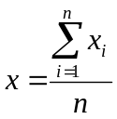 (2.1)

Volume weighted averaging (Voight)
This method takes the volume weighted average. Contributions from elements with larger volumes are larger.
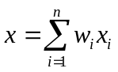, where 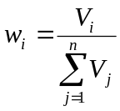 (2.2)

Inverse volume weighted averaging
This method takes the inverse volume weighted average. Contributions from elements with larger volumes are smaller.
, where 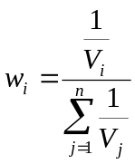 (2.3)

Element to element mapping
It is assumed that values available in the nodes of a given element mesh (the source mesh) can always be transferred to the nodes of another element mesh (the target mesh) which may be unrelated to the source mesh. To accomplish this, two methods will be described, nodal interpolation and weighted mapping.

Both methods should support the following condition:
When values are mapped from a source mesh to a target mesh, and the meshes are equal (co-located), the values in the target mesh should be equal to the values in the source mesh.

Nodal interpolation
This method will take a value for each node of the target element from the source element mesh, using the point interpolation method described in chapter 2, with one condition added:

If a node of the target element lies on the edge between two elements of the source mesh, or on a node of the source mesh, only the elements in the source mesh that overlap with the target element contribute in the averaging for the value (figure 3.1).

source mesh
target element
Figure 3.1Only the shaded source elements contribute in the nodal values for the red target element

This can only be done using non-smoothed nodal values from the source mesh. Any of the three averaging methods mentioned in paragraph 2.3 can be used.

Weighted mapping
Weighted mapping incorporates the contributions of any elements in the source mesh that lie completely within the target element. This is not the case in the nodal interpolation method. A two step approach is used. The first step is to get values from the source mesh at the intersection points with the target element, and in the original source mesh nodes within the target element (figure 3.2).
source mesh
target element
sample point
Figure 3.2Samples are taken at the intersection points with the target element and in the original source mesh nodes within the target element

These values are then input for a weighted least squares method. The weighting method can be either volume based, or inverse volume based.

The least squares method assumes there is a function description using a set of parameters that need to be resolved from a number of input values. The function we use here is the shape function of the target element:
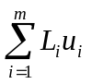 (3.1)
m is the number of nodes on the target element
L_{i} is the shape function for node i
u_{i} is the value in node i

Mapping procedure
For both volume weighted and inverse volume weighted mapping the same mapping procedure is used. The difference is the formula for the weight factors.

The function to be used for the least squares method is called R² and is defined as follows:
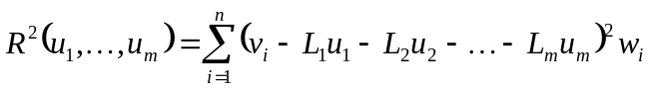 (3.2)
u₁ through u_{m} are the desired nodal values of the target element
v_{i} is the input value i (from the source mesh)
L₁ through L_{m} are the shape function values of the target element for input value i
w_{i} is the weight factor for input value i, see 2.3.2 and 2.3.3

The derivatives of this function to all desired values (u₁ through u_{m}) are set to zero.
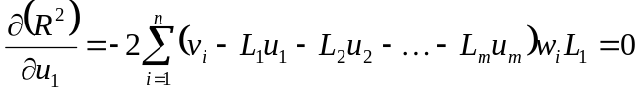 (3.3)
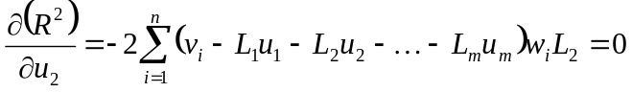 (3.4)
etc. until
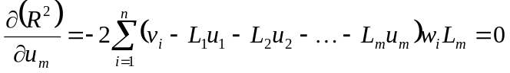 (3.5)
This gives us in matrix notation
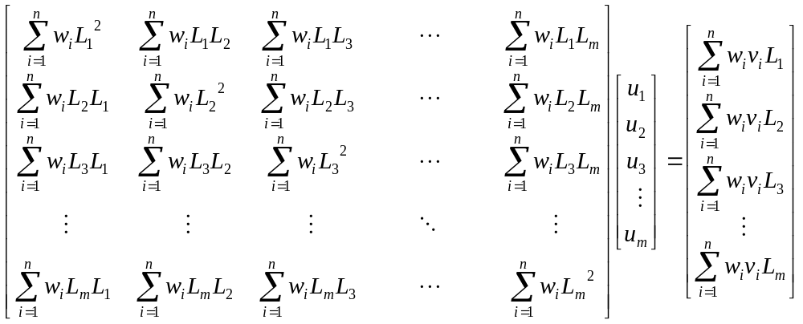 (3.6)
from which the vector can be derived by inverting the matrix.

